EXPERIMENT :6

Create a simple cloud software application for Payroll Processing System using any Cloud Service Provider to demonstrate SaaS include the necessary fields such as Name of the employee, experience in present org , over all experience, basic pay, HRA, DA, TA, net pay, gross pay etc.

**AIM:**

To Create a simple cloud software application for payroll processing system using any Cloud Service Provider to demonstrate SaaS.

**PROCEDURE:**

**step1:** Go to zoho.com.

**step 2:** Log into the zoho.com.

**step 3:** Select one application step.

**step4:** Enter application name as payroll processing system.

**step 5:** Created new application as payroll processing system.

Step 6: create a new form for Employee details

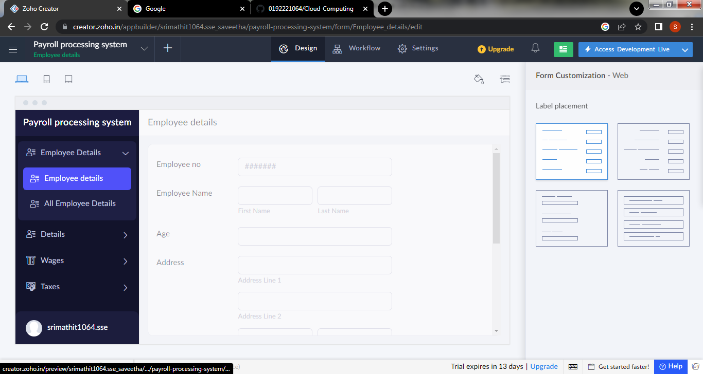

Step 7: create a second form for entering details about the working of the employee

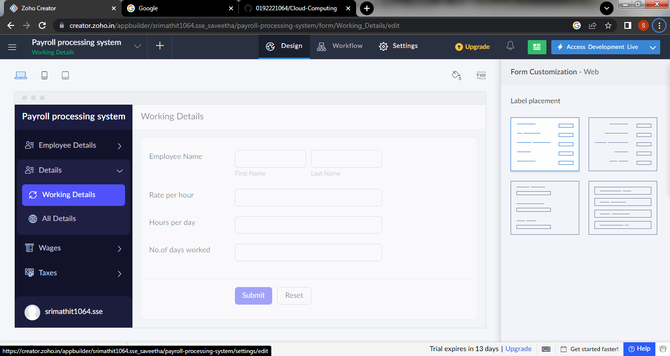

Step 8: create next form to generate the salary details of Employee

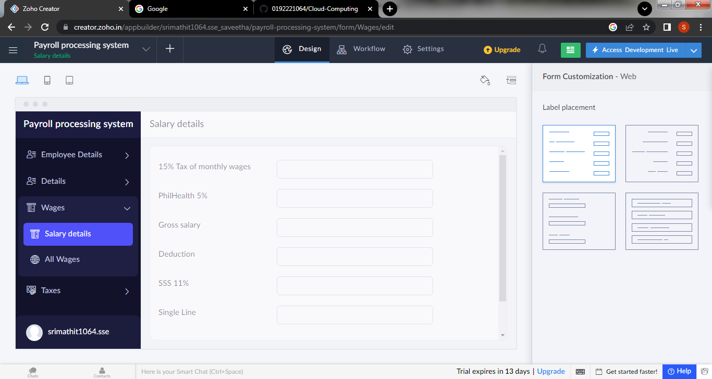

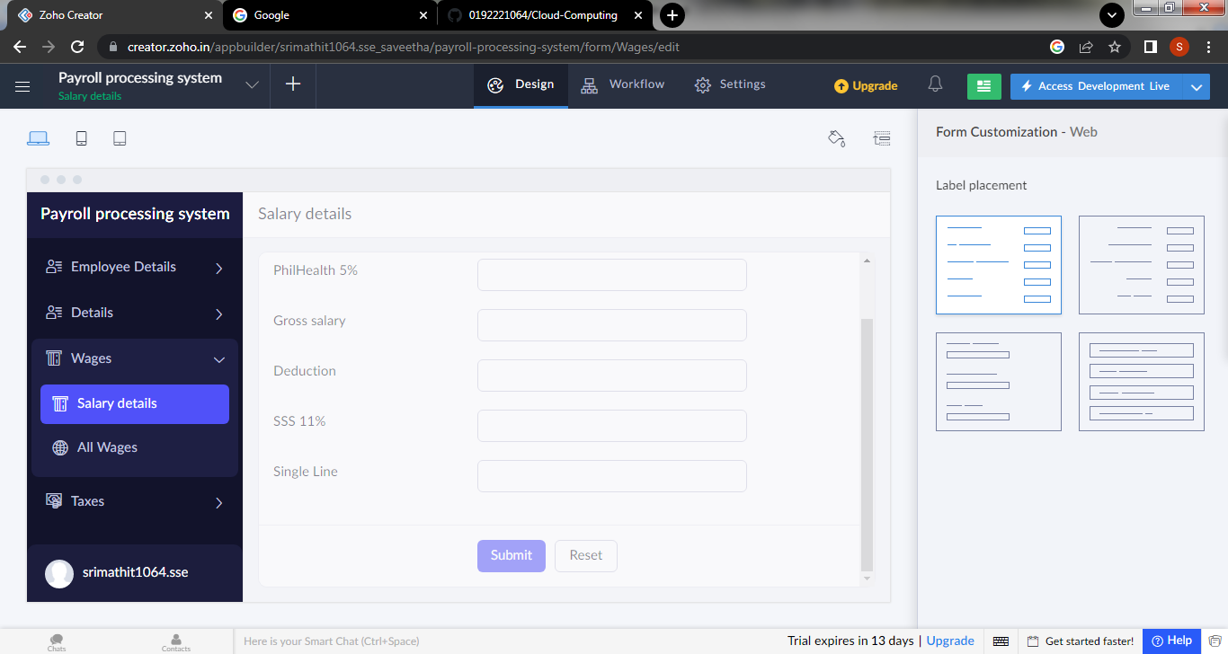

Step 9: Create a form for Taxes

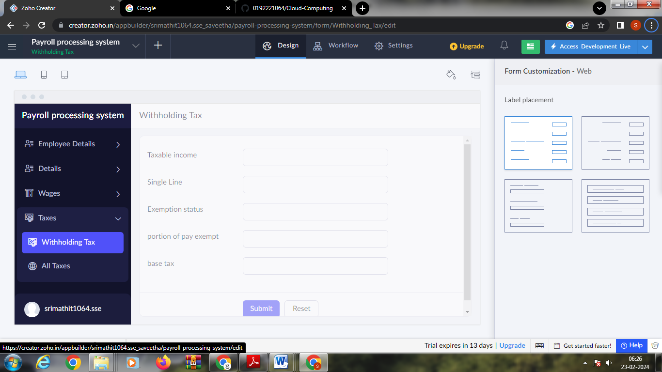

Step 10: click the access development to view the live output

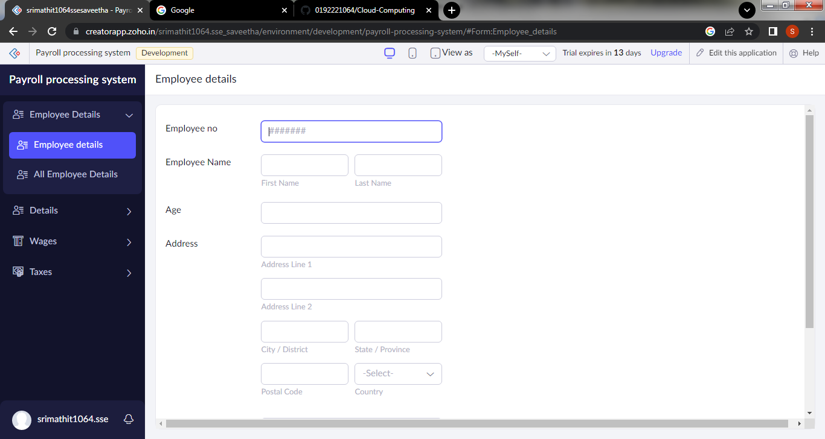

Step 11: click the report icon to view the data that are added

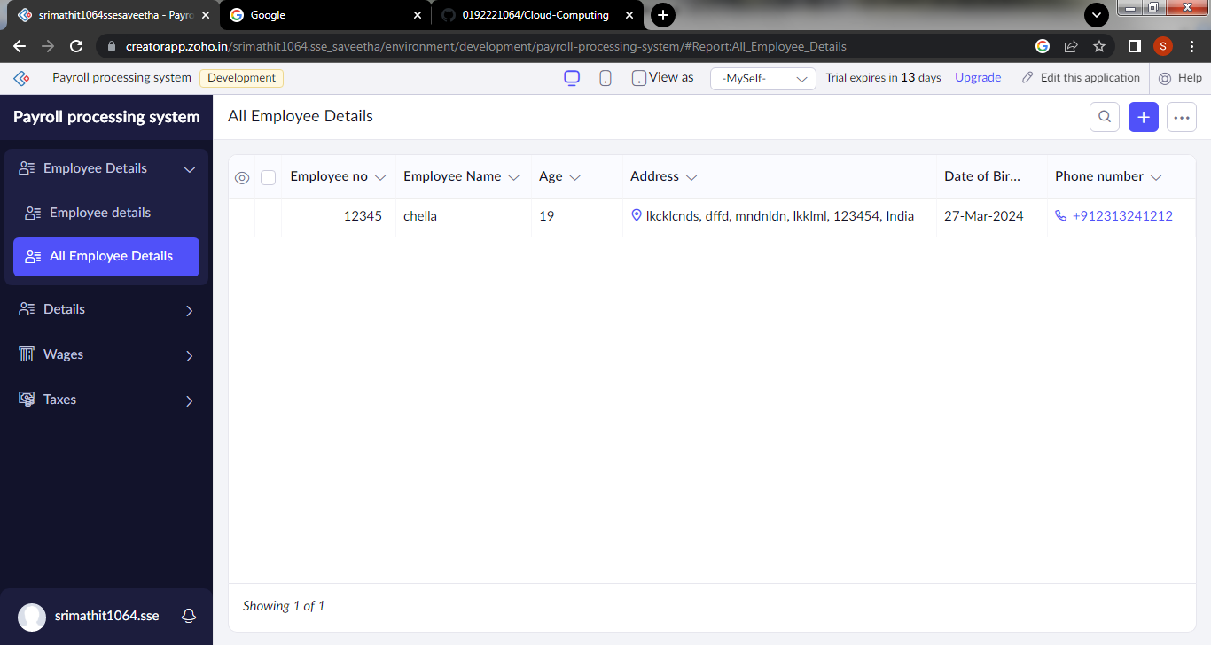

Step 12:click the mobile icon to view the output in mobile form

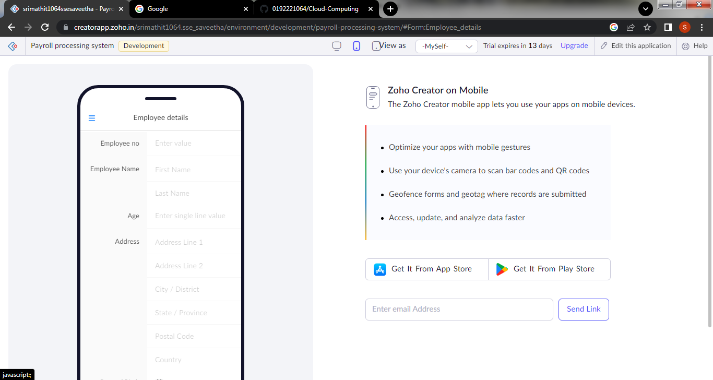

Step 13: click the tablet icon to view the output in tablet form

